Honey and Mumford: Learning Styles Questionnaire

There is no time limit to this questionnaire. It will probably take you 10-15 minutes. The accuracy of the results depends on how honest you can be. There are no right or wrong answers. If you agree more than you disagree with a statement put a tick. If you disagree more than you agree put a cross by it. Be sure to mark each item with either a tick or cross. When you have completed the questionnaire, continue this task by responding to the points that follow.

1. I have strong beliefs about what is right and wrong, good and bad.
2. I often act without considering the possible consequences.
3. I tend to solve problems using a step-by-step approach.
4. I believe that formal procedures and policies restrict people.
5. I have a reputation for saying what I think, simply and directly.
6. I often find that actions based on feelings are as sound as those based on careful thought and analysis.
7. I like the sort of work where I have time for thorough preparation and implementation.
8. I regularly question people about their basic assumptions.
9. What matters most is whether something works in practice.
10. I actively seek out new experiences.
11. When I hear about a new idea or approach I immediately start working out how to apply it in practice.
12. I am keen on self-discipline such as watching my diet, taking regular exercise, sticking to a fixed routine etc.
13. I take pride in doing a thorough job.
14. I get on best with logical, analytical people and less well with spontaneous, "irrational" people.
15. I take care over the interpretation of data available to me and avoid jumping to conclusions.
16. I like to reach a decision carefully after weighing up many alternatives.
17. I'm attracted more to novel, unusual ideas than to practical ones.
18. I don't like disorganised things and prefer to fit things into a coherent pattern.
19. I accept and stick to laid down procedures and policies so long as I regard them as an efficient way of getting the job done.
20. I like to relate my actions to a general principle.
21. In discussions I like to get straight to the point.
22. I tend to have distant, rather formal relationships with people at work.
23. I thrive on the challenge of tackling something new and different.
24. I enjoy fun-loving, spontaneous people.
25. I pay meticulous attention to detail before coming to a conclusion.
26. I find it difficult to produce ideas on impulse.
27. I believe in coming to the point immediately.
28. I am careful not to jump to conclusions too quickly.
29. I prefer to have as many sources of information as possible -the more data to mull over the better.
30. Flippant people who don't take things seriously enough usually irritate me.
31. I listen to other people's point of view before putting my own forward.
32. I tend to be open about how I'm feeling.
33. In discussions I enjoy watching the manoeuvrings of the other participants.
34. I prefer to respond to events on a spontaneous, flexible basis rather than plan things out in advance.
35. I tend to be attracted to techniques such as network analysis, flow charts, branching programmes, contingency planning, etc.
36. It worries me if I have to rush out a piece of work to meet a tight deadline.
37. I tend to judge people's ideas on their practical merits.
38. Quiet, thoughtful people tend to make me feel uneasy.
39. I often get irritated by people who want to rush things.
40. It is more important to enjoy the present moment than to think about the past or future.
41. I think that decisions based on a thorough analysis of all the information are sounder than those based on intuition.
42. I tend to be a perfectionist.
43. In discussions I usually produce lots of spontaneous ideas.
44. In meetings I put forward practical realistic ideas.
45. More often than not, rules are there to be broken.
46. I prefer to stand back from a situation and consider all the perspectives.
47. I can often see inconsistencies and weaknesses in other people's arguments.
48. On balance I talk more than I listen.
49. I can often see better, more practical ways to get things done.
50. I think written reports should be short and to the point.
51. I believe that rational, logical thinking should win the day.
52. I tend to discuss specific things with people rather than engaging in social discussion.
53. I like people who approach things realistically rather than theoretically.
54. In discussions I get impatient with irrelevancies and digressions.
55. If I have a report to write I tend to produce lots of drafts before settling on the final version.
56. I am keen to try things out to see if they work in practice.
57. I am keen to reach answers via a logical approach.
58. I enjoy being the one that talks a lot.
59. In discussions I often find I am the realist, keeping people to the point and avoiding wild speculations.
60. I like to ponder many alternatives before making up my mind.
61. In discussions with people I often find I am the most dispassionate and objective.
62. In discussions I'm more likely to adopt a "low profile" than to take the lead and do most of the talking.
63. I like to be able to relate current actions to a longer-term bigger picture.
64. When things go wrong I am happy to shrug it off and "put it down to experience".
65. I tend to reject wild, spontaneous ideas as being impractical.
66. It's best to think carefully before taking action.
67. On balance I do the listening rather than the talking.
68. I tend to be tough on people who find it difficult to adopt a logical approach.
69. Most times I believe the end justifies the means.
70. I don't mind hurting people's feelings so long as the job gets done.
71. I find the formality of having specific objectives and plans stifling.
72. I'm usually one of the people who puts life into a party.
73. I do whatever is expedient to get the job done.
74. I quickly get bored with methodical, detailed work.
75. I am keen on exploring the basic assumptions, principles and theories underpinning things and events.
76. I'm always interested to find out what people think.
77. I like meetings to be run on methodical lines, sticking to laid down agenda, etc.
78. I steer clear of subjective or ambiguous topics.
79. I enjoy the drama and excitement of a crisis situation.
80. People often find me insensitive to their feelings.

Scoring

You score one point for each item you ticked. There are no points for crossed items. Circle the questions you ticked on the list below:

 |  | 2 |  |  | 7 |  |  | 1 |  |  | 5
 |  | 4 |  |  | 13 |  |  | 3 |  |  | 9
 |  | 6 |  |  | 15 |  |  | 8 |  |  | 11
 |  | 10 |  |  | 16 |  |  | 12 |  |  | 19
 |  | 17 |  |  | 25 |  |  | 14 |  |  | 21
 |  | 23 |  |  | 28 |  |  | 18 |  |  | 27
 |  | 24 |  |  | 29 |  |  | 20 |  |  | 35
 |  | 32 |  |  | 31 |  |  | 22 |  |  | 37
 |  | 34 |  |  | 33 |  |  | 26 |  |  | 44
 |  | 38 |  |  | 36 |  |  | 30 |  |  | 49
 |  | 40 |  |  | 39 |  |  | 42 |  |  | 50
 |  | 43 |  |  | 41 |  |  | 47 |  |  | 53
 |  | 45 |  |  | 46 |  |  | 51 |  |  | 54
 |  | 48 |  |  | 52 |  |  | 57 |  |  | 56
 |  | 58 |  |  | 55 |  |  | 61 |  |  | 59
 |  | 64 |  |  | 60 |  |  | 63 |  |  | 65
 |  | 71 |  |  | 62 |  |  | 68 |  |  | 69
 |  | 72 |  |  | 66 |  |  | 75 |  |  | 70
 |  | 74 |  |  | 67 |  |  | 77 |  |  | 73
 |  | 79 |  |  | 76 |  |  | 78 |  |  | 80
Totals |  | 6 |  |  | 20 |  |  | 13 |  |  | 5
 | Activist |  |  | Reflector |  |  | Theorist |  |  | Pragmatist

Plot the scores on the arms of the cross below:

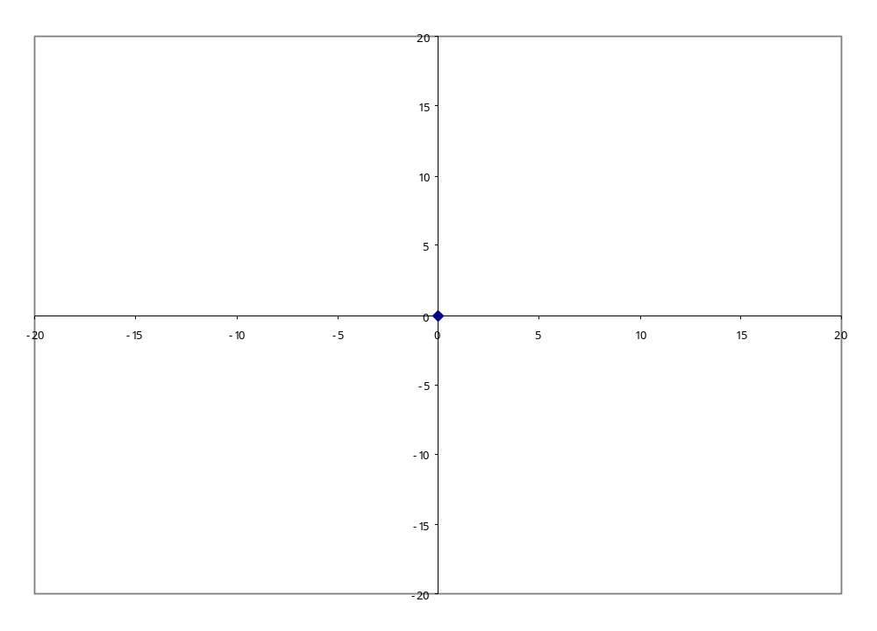
Activist
Pragmatist
Reflector
Theorist

Your result may show that you have a particular learning style. It may be useful to bear this in mind as you approach tasks. Was the approach you adopted the best one in the circumstances? Would adopting another learning style have improved your performance?

The four learning styles:
ACTIVISTS  Activists involve themselves fully and without bias in new experiences. They enjoy the "here and now" and are happy to be dominated by immediate experiences. They are open-minded, not sceptical, and this tends to make them enthusiastic about anything new. Their philosophy is: "I'll try anything once". They tend to act first and consider the consequences afterwards. Their days are filled with activity. They tackle problems by brainstorming. As soon as the excitement from one activity has died down, they are busy looking for the next. They tend to thrive on the challenge of new experiences but are bored by implementation and long-term consolidation. They are gregarious people constantly involving them-selves with others but, in so doing, they seek to centre all activity around themselves. | PRAGMATISTS  Pragmatists are keen on trying out new ideas, theories and techniques to see if they work in practice. They positively search out new ideas and take the first opportunity to experiment with applications. They are the sort of people who return from courses brimming with new ideas that they want to try out. They like to get on with things, and act quickly and confidently on ideas that attract them. They tend to be impatient with ruminating and open-ended discussion. They are essentially practical, down-to-earth people who like solving problems (often through trial and error). They view problems and difficulties as a "challenge". Their philosophy is: "As long as it works, that's fine." - although they may also be keen to experiment to find better ways to do things.
THEORISTS  Theorists adapt and integrate observations into complex but logically sound theories. They think through problems in a logical, step-by-step fashion. They assimilate disparate facts into coherent, holistic theories. They tend to be perfectionists who do not rest easy until things are tidy and fit into a rational scheme. They like to analyse and synthesise. They are keen on asking questions and challenging assumptions. Their philosophy is: "If it's logical then it's good." They attempt to fit everything together into a single jigsaw that encompasses "life, the universe and everything". They tend to be detached, analytical and dedicated to rational objectivity rather than anything subjective or ambiguous. They may rigidly reject anything that does not fit in with their own particular mind-set. | REFLECTORS  Reflectors like to stand back to ponder experiences and observe them from many different perspectives. They collect data, both first-hand and from others, and prefer to think about it thoroughly before coming to any conclusion. They tend to postpone reaching definite conclusions for as long as possible. Their philosophy is to be cautious. They are thoughtful people who like to consider all possible angles and implications before making a move. They enjoy observing other people and prefer to take a back seat in meetings and discussions. They listen to others before making their own points. They tend to adopt a low profile and have a slightly distant, tolerant unruffled air about them. When they act it is part of a wide picture which includes the past as well as the present and others' observations as well as their own.

For further information please go to: http://www.brainboxx.co.uk/a2_learnstyles/pages/LSall4.htm

